**Access Modifier**

**Protected**

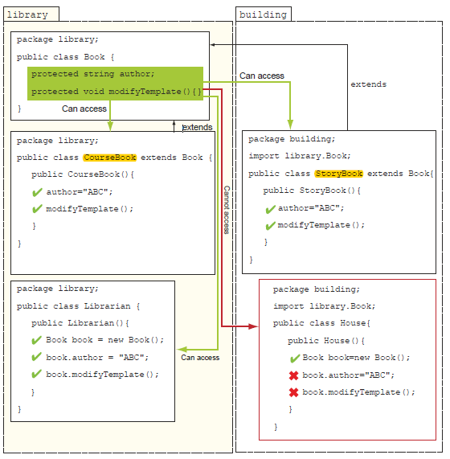

**Default package**

The members of a class defined without using any explicit access modifier are defined

with *package accessibility* (also called *default accessibility*).

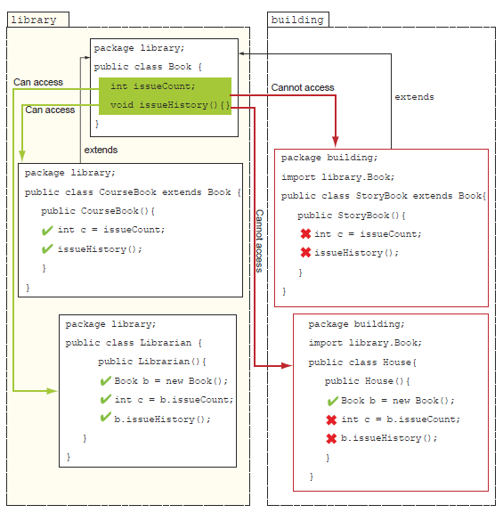

**Private Access Modifier**

*private* members are accessible only to the classes and interfaces in which they’re defined.